James Zartman
METC-279
12/19/19
Technical Report

How Steel Is Made
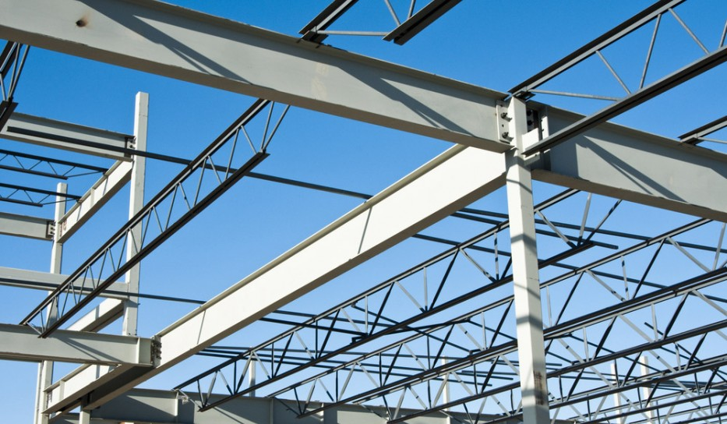
Steel has become a necessity in the world that we live in today. Steel is used in all kinds of shapes and forms to produce anything from buildings and structures (as is pictured here to the left), to automobiles, and surgical supplies. Iron ore is the raw material used to make pig iron (essentially raw iron) and is one of the raw materials used when making steel. Iron ores are rocks or minerals from which metallic irons can be extracted. Iron ore is 2nd most abundant metal in the Earth’s crust, aluminum is first. Iron ores are rich in iron oxides, where 98% of the iron ore mined is used in steel making. The whole process for how steel is made can vary significantly depending on the type of furnace being used, and what type of steel is being made. There are numerous types of processes that can be done to raw steel, as well as elements added to the process, to increase the strength, physical appearance, and longevity of the steel itself. Ultimately, the result of the steel relies heavily on what the steel is being used for.
Image source: https://www.worldcoal.org/coal/uses-coal/how-steel-produced
Ores that are Used
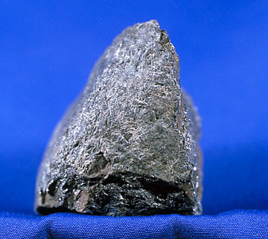
There are seven different variations of Iron ore’s, but three that are regularly mined; Hematite, Magnetite, and Taconite. Hematite is an iron ore that gets its name from the Greek word for blood, Hamia, because it has a reddish color to it. It is one of the type of ores that has a higher content of iron and is one of the ores that is most plentiful around the world. However, hematite is generally mined in Australia, Asia, and South America. Even though the mineral hematite itself has a lower iron content than other ores, it sometimes has high concentrated areas that can be mined and are referred to as Direct Shipping Ore (DSO). “This means that, due to its high iron content, such hematite ores may be mined and extracted with a fairly simple crushing and screening process before it is exported” (Types of Iron Ore). Some of the high-quality hematite contains 66% iron. Magnetite (pictured to the right) is found in banded iron formations where fine grained metamorphosed sedimentary rock is formed. This banded formation mainly consists of magnetite and silica (quartz). The main appeal of this Iron ore is its magnetism. “It is the most magnetic mineral in the world” (Types of Iron Ore). The result of mining magnetite is a much higher quality iron, with less impurities. Magnetite contains 33 to 40% iron. Finally, there is the Iron ore of Taconite. Taconite is low -grade iron ore. It is iron bearing and is found in flint like rocks in the Precambrian sedimentary rocks. There is generally less amounts of iron content in taconite, only about 25 to 30%.
Image source: http://www.miningartifacts.org/IronOres.html
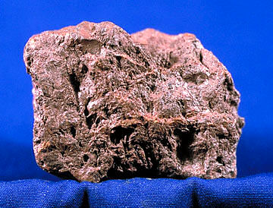
There are varied reasons why one iron ore is used over others. The main reason is availability of resources. There are some other things to take into consideration such as the cost to produce the iron, quality, and economical effects. To process magnetite and taconite requires much more work than hematite (pictured to the left) does. A lot of hematite is DSO, like was mentioned previously and doesn’t involve much more than a simple crushing and screening process. Thus, this ore would be the easiest to mine. Magnetite processing and mining requires multiple more steps than required for hematite. Since magnetite is found in banded rock formations with other unwanted minerals such as quartz, there is a lot more crushing and screening involved to get the iron by itself. This process involves, “coarse crushing and screening, followed by rough crushing and fine grinding to reduce the ore to the point where the crystallized magnetite and quartz are fine enough that the quartz is left behind when the resultant powder is passed under a magnetic separator” (Iron Ore). Taconite has smaller amounts of iron present in the layered rock. To process and mine this ore is like magnetite’s process but takes it a few steps further. Since the quality of iron produced from taconite is weak and non-usable, “the powdered iron concentrate is combined with bentonite clay and limestone as a flux and rolled into pellets about one centimeter in diameter that are approximately 65% iron” (Iron Ore). Magnetite iron ore is the best quality iron and contains little impurities such as low phosphorous, aluminum, titanium, and silica and demand a premium price. So, the excessive costs to produce and mine Magnetite can be offset by being able to charge a premium price for it. Even though, hematite is more often able to be direct shipped with little processing there is one downside to producing it. One it is not as high quality as magnetite. Second, “obtaining iron from hematite ore can produce a great deal of carbon emissions, and the process for magnetite ore is much less harmful” (Type of Iron Ore).
Image source: http://www.miningartifacts.org/IronOres.html
The Steel Making Process
Steel is an iron alloy, meaning that it is a mixture of iron and something else, typically carbon. This makes the iron much stronger and more applicable to withstand different applications. There are various ways to produce steel, but only two methods are commonly used. One of the main ways is by using an Electric arc furnace. The other more customary process that is used to produce steel is by means of a Basic Oxygen Furnace. As we will see the processes between the two different methods differs substantially.
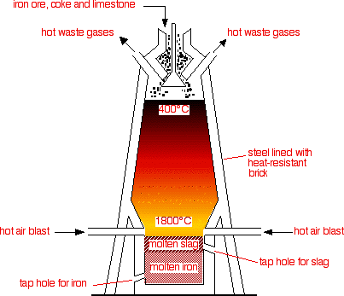
The main difference in the two main ways that steel is produced is the types of raw materials that they use. First let us look at the Basic oxygen Furnace (BOF). The Basic oxygen furnace accounts for about 75% of the steel made in the world today. This process requires the use of iron ore along with other raw elements to produce steel. “Blast furnace grade iron ore is mined as magnetite or hematite. Both minerals require additional beneficiation prior to being of sufficient quality for use in ironmaking” (Steel). The addition beneficiation of the iron ore includes; screening, grinding and a separation stage to separate out the impurities from the iron used. Direct Reduced Iron (DRI), also referred to as sponge iron due to it being porous, can also be used in the steel making process. The process to get DRI to be able to be used in a BOF is to directly reduce iron ore in its solid form. This is done by adding natural gas inside a reactor to form bricks or pellets to be used in the BOF. These bricks are also referred to as hot-briquetted iron, or HBI.

From these states of iron ore, pig iron is then created. Pig iron is made mainly by adding iron ore that is rich in iron oxide, limestone, and coke into the blast furnace. Coke is used as a fuel in the blast furnace. A diagram of a blast furnace and its components is pictured to the left. Coke is produced by igniting bituminous coal under reduced oxygen conditions inside an oven like vessel made for this process. “In the coke oven, the coal is heated to 1,800°F for up to 18 hours. During that time, the volatiles of the coal are driven into the off gas and a pure carbon form called “coke” remains” (Steel). Once the coke is cooled it can then be screened and sized to be used in the Blast Furnace. A blast furnace is a big industrial cylindrical shaped furnace where the iron ore, coke (carbon rich form of coal), and limestone are added to the top of it. Once in the Blast Furnace, the iron ore reacts chemically with the coke. The coke removes the air from the iron oxide, and leaves behind pure liquid iron. The limestone helps other unwanted parts of the ore, such as sand, clay, and small stones. These unwanted parts of the ore are called slag. “The iron made in a blast furnace is an alloy containing about 90–95 percent iron, 3–4 percent carbon, and traces of other elements such as silicon, manganese, and phosphorus, depending on the ore used. Pig iron is much harder than 100 percent pure iron, but still too weak for most everyday purposes” (Iron and Steel). From the Blast Furnace the molten pig iron is then moved on to the BOF.
Image source: https://www.chemguide.co.uk/inorganic/extraction/iron.html
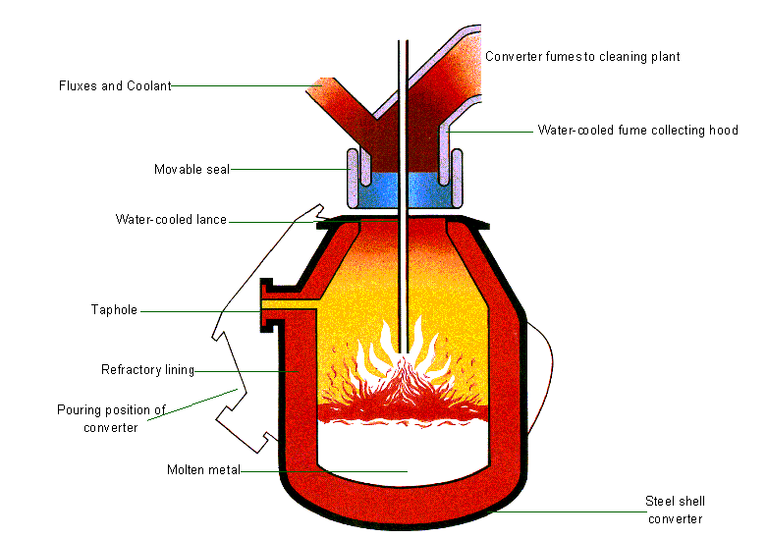
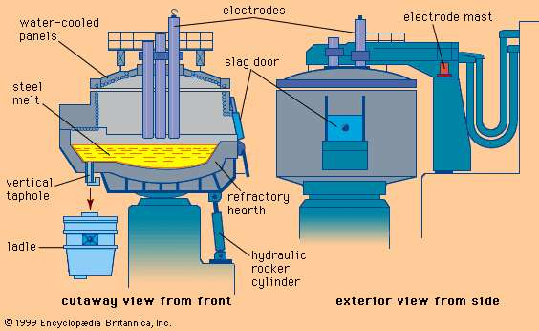
In the BOF process the furnace starts off tilted at 45 degrees towards the charging aisle. In this state, the scrap and molten pig iron are added together in the furnace. This part of the process is called charging and takes a few minutes. After the charging is complete the furnace is turned back upright. At this point fluxing agents are added to the charged material such as lime/dolomite. Simultaneously the oxygen lance is lowered to approximately 1 foot above the bottom of the vessel. The picture above shows the lance inserted into the furnace and the process of melting the material is started. The lance is water-cooled and has a copper tip with hole in it. “Through this lance, oxygen of greater than 99.5% purity is blown into the mix. If the oxygen is lower in purity, nitrogen levels at tap become unacceptable” (Steel). The oxygen is blown into the vessel for a predetermined time which is typically 15 to 20 minutes. During this time, the agitation of oxygen refines the molten metal and produces carbon and carbon dioxide. Once the lance is done blowing oxygen and the vessel is ready to be tapped, the vessel tips towards the tapping aisle and transferred into a steel ladle. After the molten metal is transferred into the steel ladle, the vessel is turned completely upside down and the slag is discarded into the slag pot. The process then starts over.
Image source: https://www.steelconstruction.info/File:BOS_diagram_cropped.PNG
Image source: https://www.britannica.com/technology/electric-furnace
The other type of furnace commonly used is the Electric Arc Furnace (EAF). This furnace (pictured above) uses electric current via electrodes to melt the metal to become usable to make new steel. This process does not require the process of iron making like the BOF does. The EAF has mainly scrap metal that is poured into the furnace and is then heated up by powerful electrical current. This then becomes molten. Sometimes pig iron or DRI is used to help balance out the composition of the materials being melted. “The EAF operates on the basis of an electrical charge between two electrodes providing the heat for the process. The power is supplied through the electrodes placed in the furnace, which produce an arc of electricity through the scrap steel (around 35 million watts). This raises the temperature to 1600˚C, melting the scrap” (World Coal). After the scrap is melted the impurities can be removed by adding fluxes, such as limestone. This furnace also has the capability to pour off the slag through a tap hole.
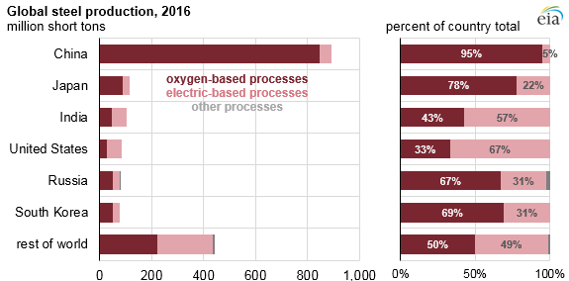

Image source: https://www.eia.gov/todayinenergy/detail.php?id=34052
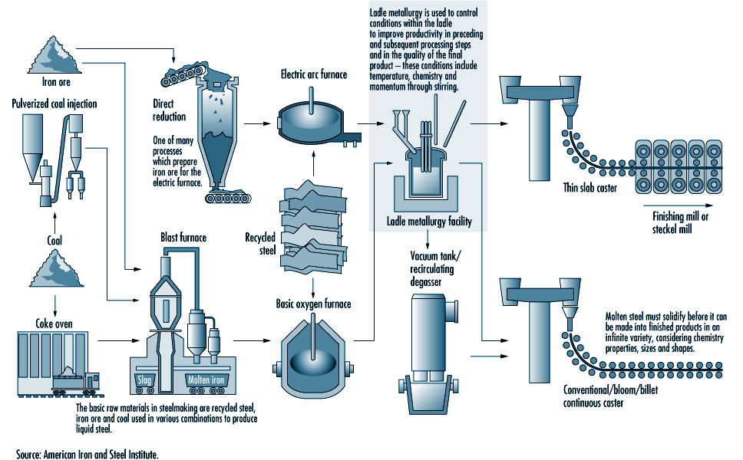
Both furnaces have their advantages and disadvantages. The Basic Oxygen Furnace is one that has been widely used since the 50’s. As seen from the chart above the oxygen-based processes are the most used. In china 95% of all the steel made in 2016 was from an oxygen-based furnace. The advantage of the BOF is that there is not a limiting factor as to what can be used to make steel. For example, the Electric Arc Furnace uses mainly scrap steel to produce steel. There could end up being a shortage of it and thus would limit a facilities ability to produce new good steel. Also, the making of Iron ore allows the steel maker to dictate how much iron ore they will have on hand, so they don’t run out. The disadvantage of the BOF is that they take up a lot of space and they produce a lot of CO₂ emissions which in the world that we are growing in, emissions are a ever growing issue and concern. The EAF is more controllable and for that reason is used to make higher specification alloy, carbon, and tool steels. Ultimately, either one of these furnaces would work just fine to produce steel. Below is a flow chart of how steel is made from start to finish.
Image source: http://www.ilocis.org/documents/chpt73e.htm

What happens next
From this point the molten steel from either one of the furnaces can move on to be refined even more in its molten state or it can be produced into things such as bars called ingots. From ingots then the material can be rolled into what are called plates and for forging. Plates are where the ingots are hot rolled into a certain thickness. The more that the plates are worked and tempered, the stronger the metal will be. Once the thickness is achieved the plate is cooled and then cut to specified lengths. These lengths can then be welded into circular pipe. For example, Forging is taking the ingots and then molding the solid piece of steel into the shape close to the result being looked for. This then can be machined the rest of the way. Typically, these are things such as camshafts. Instead of ingots the hot steel can be formed into slabs where they can then be hot rolled into strips which are then rolled into a coil. From there the hot rolled coil can be sent to a pickling line where the surface of the steel gets chemically treated to remove rust or any other contaminant. From pickling the rolled coil of steel can then be cold rolled which rolls out the metal even thinner which increases its strength along with making it more brittle. To counteract the brittleness the cold rolled steel will then usually be annealed, which is a heat treatment to make the steel more ductile and workable. Finally, the cold roll could then be galvanized, or tin plated which would result in putting a protective coating on the steel to prevent rust or oxidation from occurring. The more processes the steel sees the seemingly more expensive the bill can get (Steel).
To conclude, steel is one of the biggest necessities in our world today. The oldest most essential way to make steel is to start out with iron ore and melt it down in a basic oxygen furnace or an electric arc furnace. As discussed above, the methods of these furnaces vary greatly. Both types of furnaces provide advantages and disadvantages. There are multiple ways that the molten metal can then be made into various items to be used in structures, the auto industry, railroads, and many other applications. It truly is an engineering feat to be able to do so much with Steel nowadays.

References

“Iron Ore”. Miningartifacts.org
<http://www.miningartifacts.org/IronOres.html>. Accessed 19 December 2019

“Types of Iron Ore”. Investigatingnews.com
<http://investingnews.com/daily/resource-investing/base-metals-investing/iron-investing/types-of-iron-ore-hematite-vs-magnetite/>. Accessed 19 December 2019

“Iron and Steel”. Explainthatstuff.com
<http://www.explainthatstuff.com/ironsteel.html>. Accessed 19 December 2019

“About Steel”. Worldsteel.org
<https://www.worldsteel.org/about-steel.html>. Accessed 19 December 2019

“World Coal”. Worldcoal.org
< https://www.worldcoal.org/coal/uses-coal/how-steel-produced>. Accessed 19 December 2019

“Steel”. Steel.org
< https://www.steel.org/steel-technology/steel-production >. Accessed 19 December 2019

